Design and Development Document
Design Overview
The application was designed as a Zoo Management System using object-oriented programming principles. The main aim of the design was to separate responsibilities across different classes so that the program is easier to understand, maintain and extend. Instead of placing all code in one class, the system uses a superclass, subclasses, interfaces and a manager class.
The core superclass is Animal, which stores shared attributes such as name, age, colour and weight. Specific animals such as Lion, Parrot, Dolphin and Penguin inherit from Animal. This avoids repeated code and demonstrates inheritance, as each animal shares common properties but also has its own unique behaviour.
Object-Oriented Principles
Inheritance is used through the relationship between Animal and the animal subclasses. For example, Lion extends Animal, meaning the lion class inherits shared fields and methods from the parent class.
Polymorphism is demonstrated through the makeSound() method. The Animal class defines this as an abstract method, but each subclass provides its own version. This means the program can store different animal objects in a single ArrayList ‘Animal’ and call animal.makeSound(), with Java automatically running the correct version depending on the animal type.
Interfaces were also used to represent behaviours that only some animals can perform. Flyable is implemented by Parrot, while Swimmable is implemented by Dolphin and Penguin. This design is better than forcing all animals to have swimming or flying behaviour, because not every animal can perform these actions.

UML Diagram
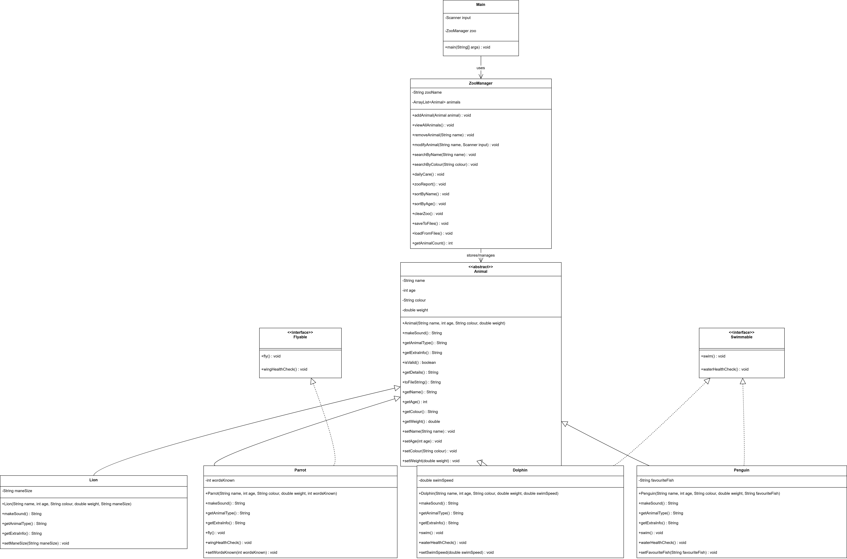
Data Structures and Control Structures
An ArrayList ‘Animal’ was chosen to store the animals because it allows multiple animal objects to be added, removed, searched and sorted dynamically. This is more suitable than a fixed array because the number of animals in the zoo can change during runtime.
A HashMap<String, Integer> was used in the zoo report to count the number of animals by colour and identify the dominant colour. This was chosen because it allows each colour to be stored with a matching count.
The program uses if statements to validate user input and check whether animals implement interfaces such as Flyable or Swimmable. A switch statement is used in the menu system to control which feature runs based on the user’s choice. Loops are used to repeatedly display the menu and to process all animals in the collection.
Development Decisions
The application was developed using a menu-driven structure in Main, while the main logic was placed in ZooManager. This separates user interaction from system processing, making the program easier to manage. Additional features such as sorting animals by name or age, preventing duplicate names and clearing the zoo were added to improve usability and show further use of collections and validation.
Overall, the design demonstrates inheritance, polymorphism, interfaces, collections and structured program control, which supports the requirements of the assignment.

